



Maheswari Public School

**Project File SESSION 2023 - 24**



Name: Aryan khandelwal and Vidhan khandelwal

Subject: information practice

Roll No:...................

Topic: python databases

ACKNOWLEGEMENT

I would like to express my gratitude towards my Information Practices teacher MRS MANISHA NARUKA for her valuable guidance and nonstop support during this project. As well as, I am grateful to our principal SMT. RITA P. TANEJA for providing me with the beautiful opportunity to work on this Project. I would also like to thank my parents and friends for encouraging me during the course of this project. Finally, I would like to thank the CBSE board for giving me this great opportunity to do this project

CERTIFICATE

This is to certify that Aryan Khandelwal, student of class 12thA2 has successfully completed the research on the project “Trend of electric vehicle in India using Data Visualization” under the guidance of MRS MANISHA NARUKA during the year 2024-25. The certified student has been dedicated throughout her research and completed her work before the given deadline without missing any important details from the project. It is also certified that this project is the individual work of the student and can be submitted for evaluation.

Teacher’s Signature.

Principal Signature.

External Examiner:

|  |  |
| --- | --- |
| iNTRODUCTION TO PYTHON | wHAT IS PYTHON  Python is a popular programming language. It was created by Guido van Rossum, and released in 1991. It is  used for:   * **web development (server-side)** * **software development,** * **mathematics,** * **system scripting.** |

|  |  |
| --- | --- |
| what python can do | 1. Python can be used on a server to create 2. web applications. 3. Python can be used alongside software to create workflows. 4. Python can connect to database systems. It can also read and modify files. 5. Python can be used to handle big data and perform 6. complex mathematics. Python can be used for rapid prototyping, or for production-ready software development. |

|  |  |
| --- | --- |
| Why python | Python works on different platforms (Windows, Mac, Linux, Raspberry Pi, etc).    Python has a simple syntax similar to the English language.  Python has syntax that allows developers to write programs with fewer lines than some other programming languages.  Python runs on an interpreter system, meaning that code can be executed as soon as it is written. This means that prototyping can be very quick.  Python can be treated in a procedural way, an object-oriented way or a functional way. |

***Objective***

**the quote speaks, Data visualization helps to derive information insights from data sources in a better way.**

**SO, through this, I want to display Trend and sales report of electric vechile in india for last 4 year report [2020-23]**

“**EVERY PICTURE TELL STORY** “

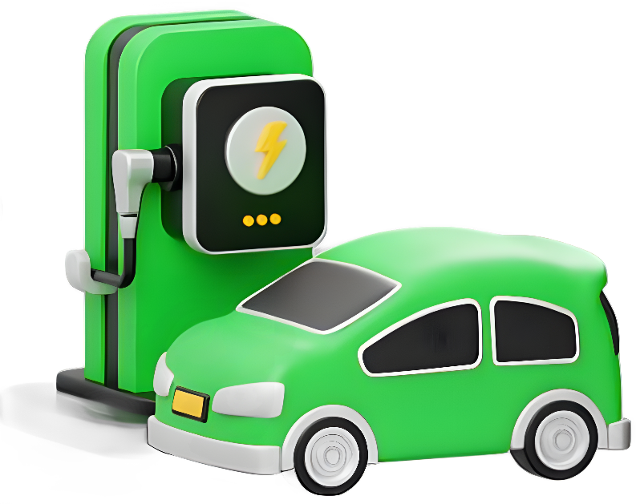

The Trend of Electric Vehicles in India

Analysis



Demand of electrical vehical in india

**CSV FILE**

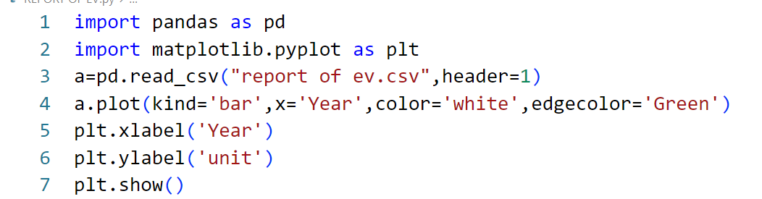

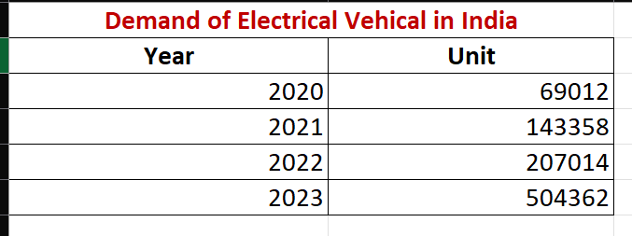

**PROGRAM**

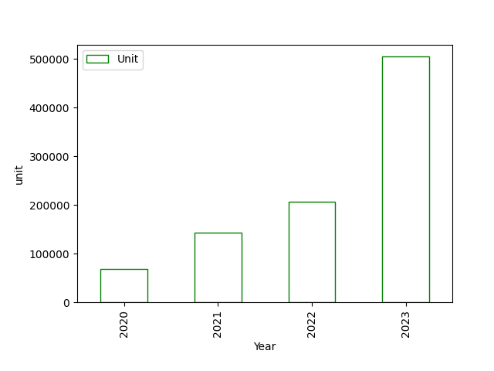

**OUTPUT**

**Analysis**

The provided data shows the demand for electric vehicles (EVs) in India over a span of four years:

- In 2020, the demand for electric vehicles in India was 69,012 units.

- This demand surged in 2021, reaching 143,358 units, indicating a significant increase.

- By 2022, the demand further rose to 207,014 units, continuing the upward trend.

- In 2023, there was a substantial leap in demand, skyrocketing to 504,362 units.

This data suggests a remarkable growth in the adoption of electric vehicles in India over the specified period. Factors contributing to this increase could include governmental incentives, growing awareness of environmental concerns, advancements in EV technology, and the expansion of EV infrastructure across the country.

Demand of electrical vehical in india

**CSV FILE**

State-wise measures to boost EV sales

**CSV FILE**

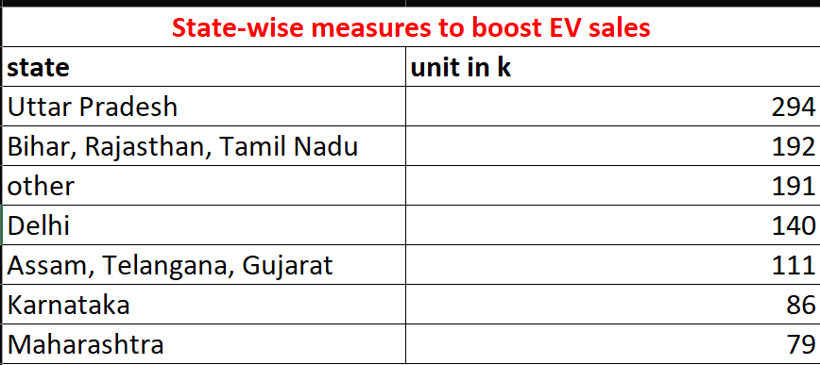

**PROGRAM**

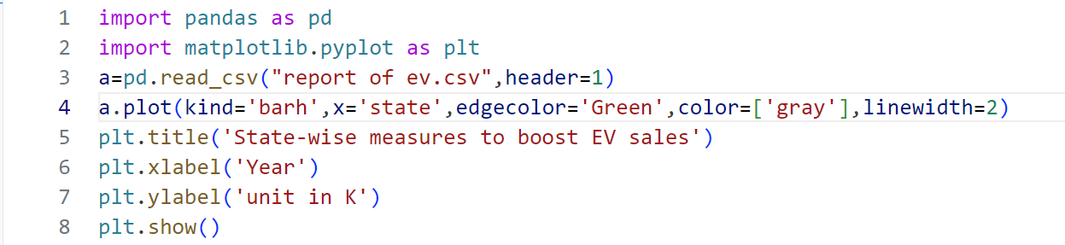

**OUTPUT**

**Analysis**

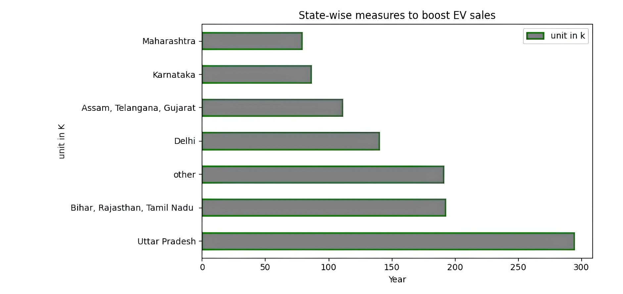

The data indicates varying levels of electric vehicle (EV) sales across different Indian states:

- **Uttar Pradesh** leads with 294k units, likely due to government incentives and rising environmental awareness.

- **Bihar, Rajasthan, and Tamil Nadu** follow closely with 192k units, showing a collective interest in EV adoption.

- **Other states** collectively contribute 191k units, suggesting scattered but significant interest nationwide.

- **Delhi's** 140k units indicate moderate adoption despite pollution concerns.

- **Assam, Telangana, and Gujarat** show moderate interest with 111k units.

- **Karnataka, Maharashtra, and other st**ates exhibit varying levels of interest, highlighting opportunities for targeted strategies to boost EV sales nationwide.

Vehicle Category-wise Market Share (Apr-2014-Mar2023)

**CSV FILE**

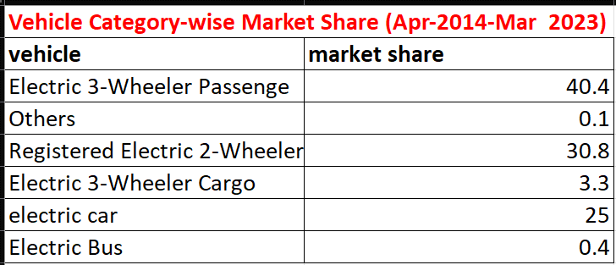

**PROGRAM**

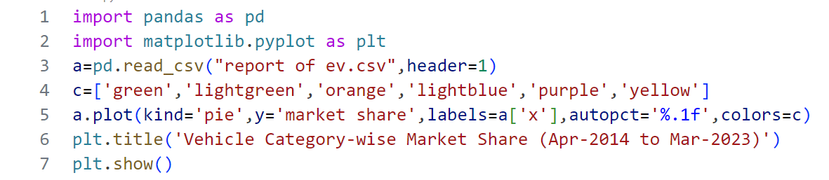

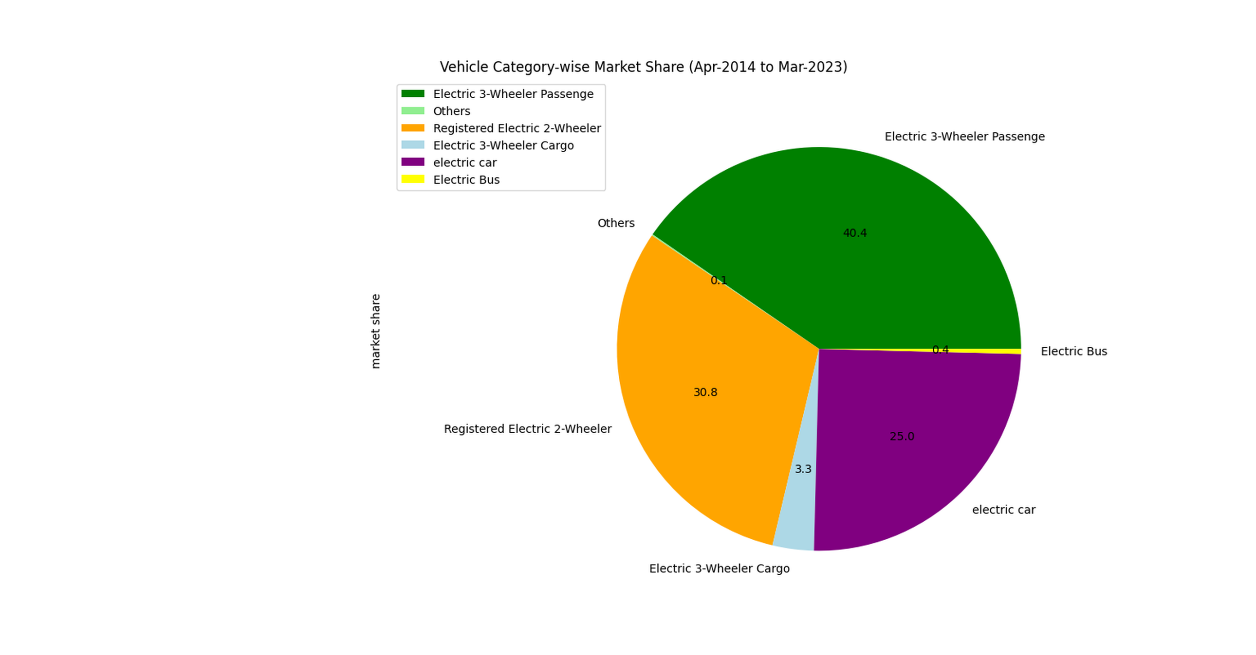

**OUTPUT**

**Analysis**

The data from April 2014 to March 2023 shows:

1. **Electric 3-Wheelers Lead**: They hold the largest share (40.4%), preferred for short urban commutes.

2. **Rise of Electric 2-Wheelers**: They account for 30.8%, indicating growing acceptance, driven by fuel prices and incentives.

3. **Electric Cars on the Horizon**: With a 25% share, they show promise despite being smaller compared to traditional vehicles.

4. **Challenges for Buses and Cargo 3-Wheelers** Their shares are low (0.4% and 3.3% respectively), likely due to infrastructure and cost issues.

5. **Niche Market for Others**: Including bikes and specialty vehicles, they contribute only 0.1%.

In conclusion, while electric vehicle adoption is positive, there's room to grow in buses and cargo. Efforts in infrastructure and incentives are crucial for a sustainable transportation shift.

- Karnataka, Maharashtra, and other states exhibit varying levels of interest, highlighting opportunities for targeted strategies to boost EV sales nationwide.

Sales of electrical car & TWO-WHEELER (Apr-2020 to Mar2023)

**CSV FILE**

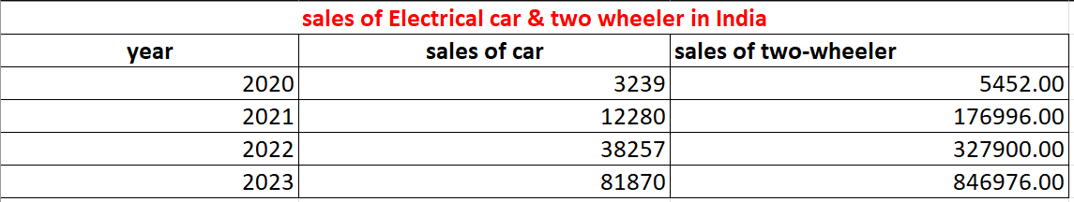

**PROGRAM**



**OUTPUT**

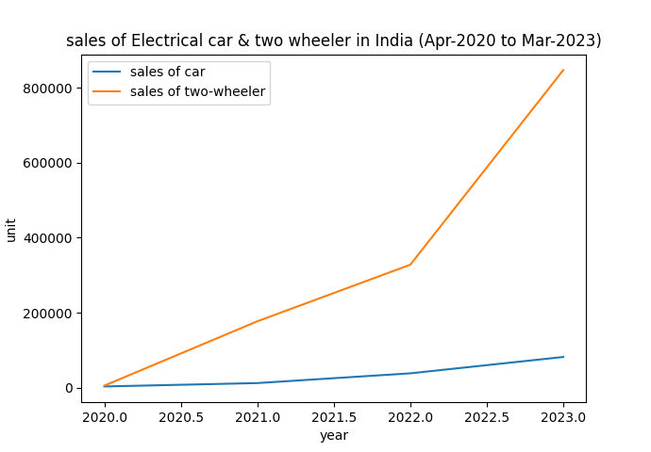

**Analysis**

In just a few years, electric cars and two-wheelers have become more popular in India. In 2020, only a few thousand electric cars were sold, along with about 55,000 electric two-wheelers. But by 2023, these numbers had skyrocketed. Over 81,000 electric cars and nearly 847,000 electric two-wheelers were sold. This big jump shows that more people are choosing electric vehicles.

The reasons for this increase are clear. People are worried about pollution and want cleaner ways to travel. Also, the government is supporting electric vehicles with incentives and policies.

But there are still challenges. More charging stations are needed, and electric vehicles need to become cheaper. People also worry about how far they can travel on a single charge.

In short, while electric vehicle sales in India have grown a lot, there's still work to do to make them even more popular.

Top 5 electric Four-wheeler company in India

**CSV FILE**

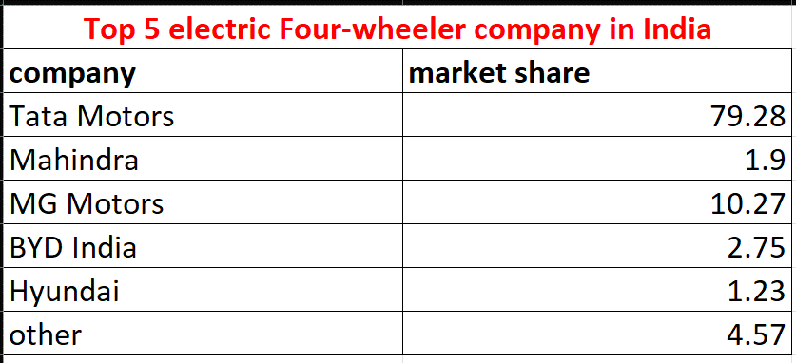

**PROGRAM**

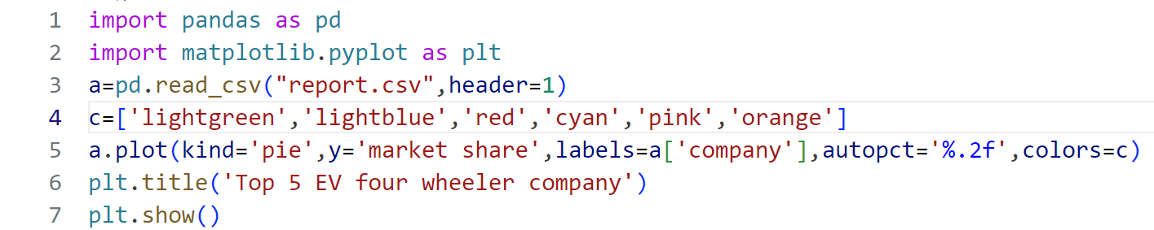

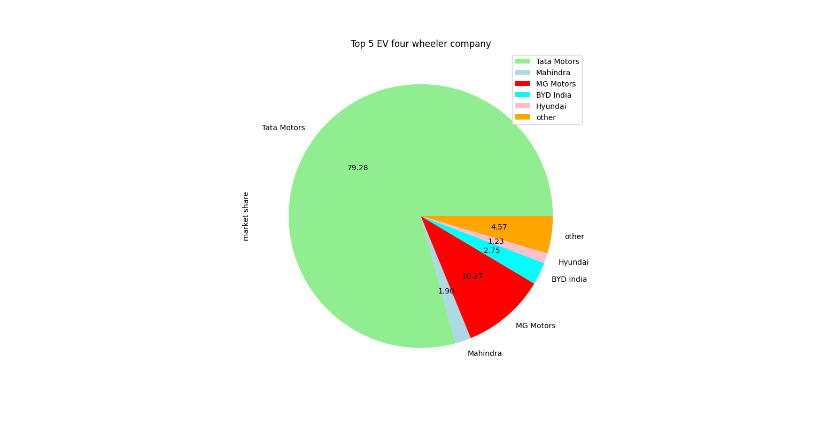

**OUTPUT**

1. **Tata Motors**: Leading with a 79.28% market share, Tata Motors dominates the Indian electric four-wheeler market. Their strong presence and early entry into the EV space with models like the Nexon EV and Tigor EV have been well-received.

2. **MG Motors**: Holding a 10.27% market share, MG Motors is a distant second. Despite being new to the Indian market, their models such as the MG ZS EV and MG Hector EV have quickly gained popularity.

3. **BYD India**: With a 2.75% market share, BYD India is growing but still behind the top two. Their models, including the BYD e1 and BYD e2, are gaining traction.

4. **Hyundai**: At a 1.23% market share, Hyundai is expanding its EV range with the Hyundai Kona Electric and Hyundai Ioniq Electric but remains behind in market share.

5. **Mahindra**: With a 1.9% market share, Mahindra, despite being an early mover with models like the Mahindra e-Verito and e-Supro, is struggling to keep pace with the top competitors.

In summary, Tata Motors leads the Indian electric four-wheeler market, followed by MG Motors and BYD India, with Hyundai and Mahindra trailing behind.

**Analysis**

Top 5 electric two-wheeler OEMs in India

**CSV FILE**

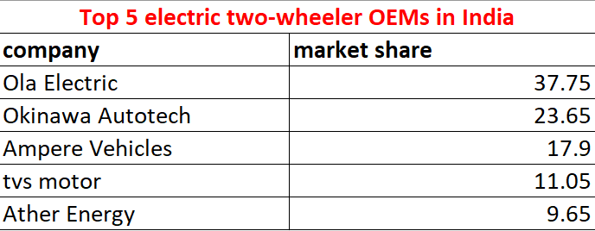

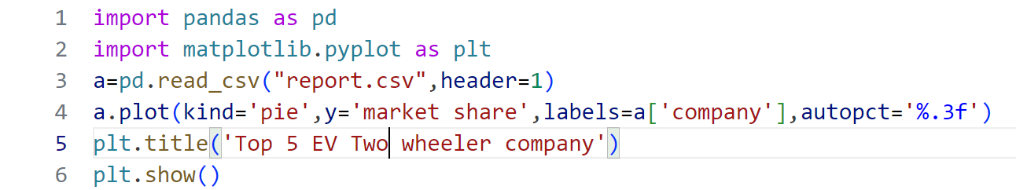 **PROGRAM**

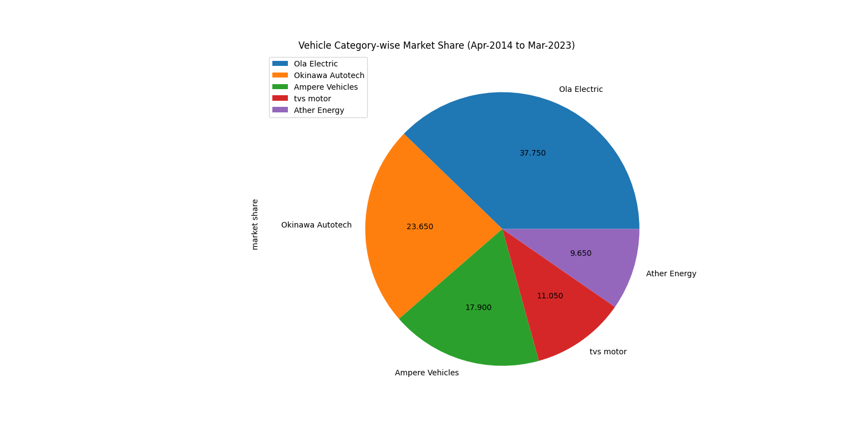

**OUTPUT**

Top 5 EV three- wheeler company

**Analysis**

The data reveals that Ola Electric is the clear market leader in the Indian electric two-wheeler market, with a staggering 75.5% market share. This is not surprising, given that Ola Electric is a subsidiary of Ola, one of the largest ride-hailing companies in India, which has a strong presence in the country.

**Okinawa Autotech** is the second-largest player in the market, with a 47.3% market share. The company has been a pioneer in the development of electric two-wheelers in India and has a wide range of products, including the Okinawa Praise and Okinawa Ridge.

**Ampere Vehicles** is another significant player in the market, with a 37.8% market share. The company has been focused on developing affordable and accessible electric two-wheelers, and has launched several popular models, including the Ampere Reo and Ampere V48.

**Tvs Motor** is the fourth-largest player in the market, with a 22.1% market share. The company has been investing heavily in electric two-wheeler technology and has launched several new models in recent years.

**Ather Energy** is the fifth-largest player in the market, with a 19.3% market share. The company has been gaining popularity in recent years, thanks to its innovative products, including the Ather 450 and Ather 340.

Top 5 electric three-wheeler OEMs in India

**CSV FILE**

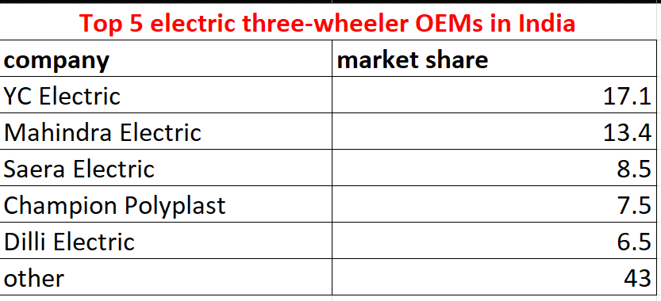

**PROGRAM**

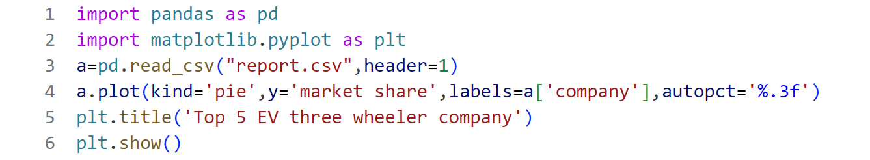

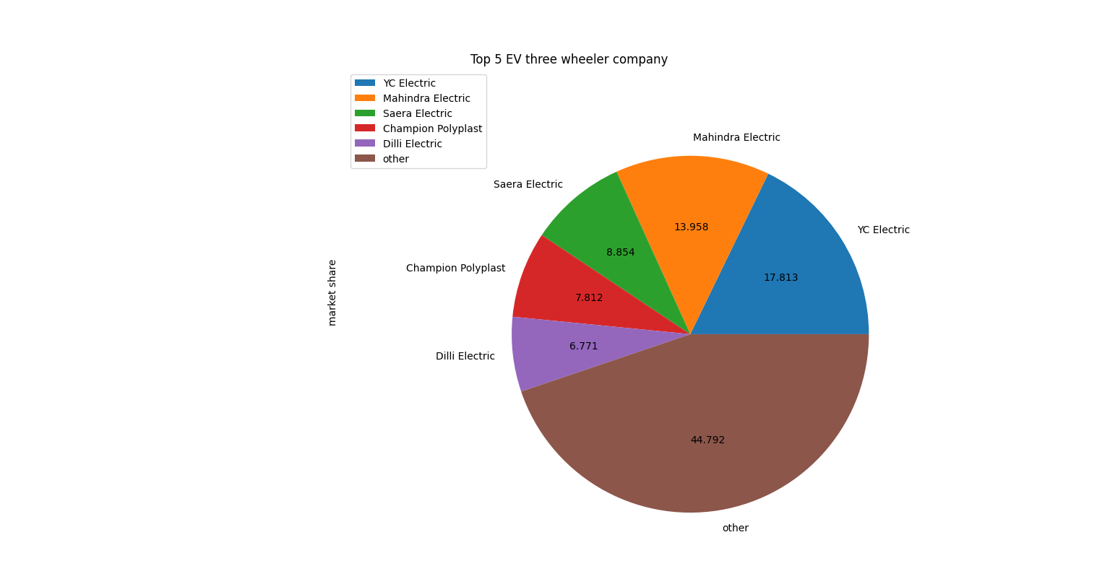

**OUTPUT**

Top 5 EV three- wheeler company

These five OEMs dominate the Indian electric three-wheeler market, accounting for a combined market share of around 42.5%. The remaining 43% of the market is shared by other OEMs and smaller players.

The dominance of these five OEMs can be attributed to their strong brand presence, extensive dealership networks, and wide range of products catering to different customer segments. They have also invested heavily in research and development, manufacturing, and marketing to stay competitive in the market.

In conclusion, the Indian electric three-wheeler market is dominated by a few prominent OEMs, with YC Electric leading the pack. The competition is intense, and smaller players will need to innovate and adapt to remain relevant in the market. As the demand for electric vehicles continues to grow, it will be interesting to see how these OEMs evolve and respond to changing customer needs and regulatory requirements.

**Analysis**

Top 5 electric BUS company in India

**CSV FILE**

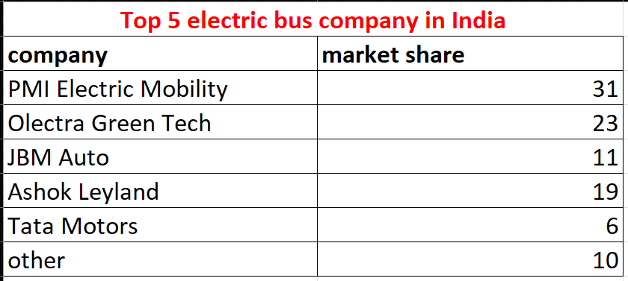

**PROGRAM**

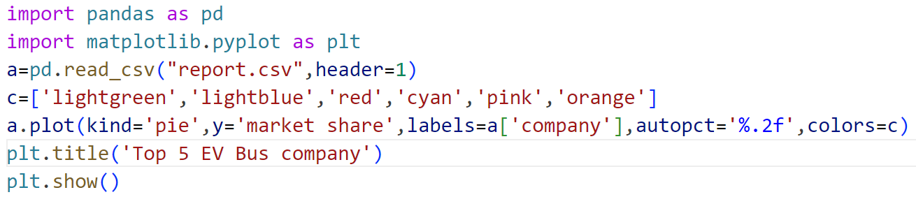

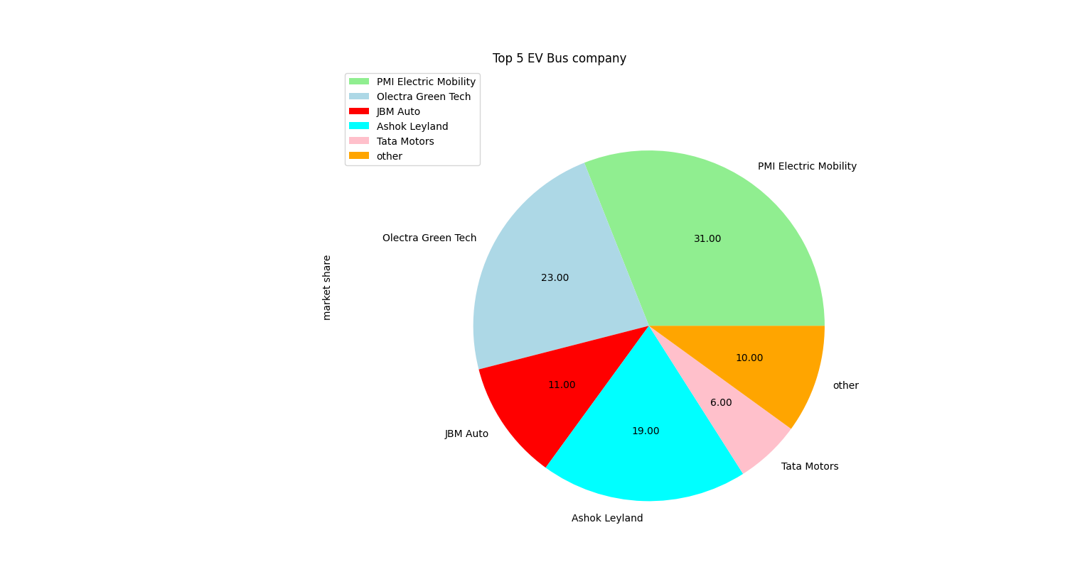

**OUTPUT**

Analysis of Top 5 Electric Bus Companies in India

Based on the market share data, it is clear that PMI Electric Mobility is the leading player in the Indian electric bus market, with a significant 31% market share. This is likely due to the company's focus on electric buses and its extensive range of products, including the PMI Star and PMI Eagle.

**Olectra Green Tech** is a close second, with a market share of 23%. The company has been a pioneer in the development of electric buses in India and has a strong presence in the market. Its range of electric buses, including the Olectra STAR and Olectra PRO, is popular among customers.

**JBM Auto** is a relatively smaller player in the Indian electric bus market, with a market share of 11%. However, the company has been making significant strides in the development of electric buses and has launched several new models in recent years.

**Ashok Leyland** is another major player in the Indian electric bus market, with a market share of 19%. The company has been expanding its range of electric buses in recent years and has launched several new models, including the Ashok Leyland e-Bus and Ashok Leyland EcoLife.

**Tata Motors**, one of the largest automotive companies in India, has a relatively smaller market share in the electric bus segment, with a 6% market share. Despite its strong presence in the Indian automotive market, Tata Motors has been slower to adopt electric buses compared to other players.

Other companies, including those that are not listed in the top 5, account for 10% of the market share. These companies may be smaller players or new entrants in the market.

Overall, the data suggests that PMI Electric Mobility is the clear leader in the Indian electric bus market, followed by Olectra Green Tech and JBM Auto. Ashok Leyland and Tata Motors are also significant players in the market, but have smaller market shares.

4. **Hyundai**: With a market share of 1.23%, Hyundai is another major player in the Indian electric four-wheeler market. Hyundai has been expanding its range of electric vehicles in India, including the Hyundai Kona Electric and Hyundai Ioniq Electric. However, despite its strong brand presence in India, Hyundai still lags behind the top three players in terms of market share. [[1]](https://www.team-bhp.com/news/electric-vehicle-sales-india-2-companies-command-98-market)

5. **Mahindra**: With a market share of 1.9%, Mahindra is another major player in the Indian electric four-wheeler market. Mahindra has been a pioneer in the development of EVs in India, and its range of electric vehicles, including the Mahindra e-Verito and Mahindra e-Supro, has been popular among customers. However, despite its early mover advantage, Mahindra has been struggling to maintain its market share in recent years. [[1]](https://www.team-bhp.com/news/electric-vehicle-sales-india-2-companies-command-98-market)

Overall, the data suggests that Tata Motors is the dominant player in the Indian electric four-wheeler market, followed by MG Motors and BYD India. Hyundai and Mahindra are also significant players in the market, but they trail behind the top three players in terms of market share.

Please note that the market share data provided is based on the available search results and may not reflect the most up-to-date information.

**Analysis**